* What Is An AI Website Builder?

An AI website builder is, put simply, any website builder that uses artificial intelligence to help in the creation and management of the website. The first AI tool to be made available for website owners was chatbots to answer customer queries, but then in 2016, Wix unveiled its Wix Artificial Design Intelligence (ADI), which could create a custom website template based on answers from a short questionnaire. Now, with language learning models (LLM) like ChatGPT, AI can create custom text based on a short prompt.

An important thing to take away though is this: **AI cannot create, it can only copy**. AIs learn through being fed loads of data, and their answers will only be as good as their library.

**Wix Website Creator-**

Wix is also first on this list for having the best overall AI features. Wix has the distinction of being the first website builder to majorly utilize AI with Wix ADI back in 2016.

With AI, Wix ADI was able to significantly speed up the website-building process by creating a custom template for new visitors rather than them having to pick one themselves. It also helps that Wix is one of the easiest-to-use website builders

Wix ranks highly in most of our categories, especially features and design. Wix’s design and templates work in tandem with its ADI and lead to some seriously great-looking templates.

Wix comes with a full library of amazing features for each and every industry such as an online store, bookings, events, community manager, members areas, and more.

**Wix Overview**

**Wix ADI is Wix’s premier AI feature**. Instead of picking a template to get started, we should answer a short questions, and then Wix uses artificial intelligence to build a tailored template for based on the information given it. can’t put in a custom answer or prompt, like Hostinger’s AI Website Builder. Instead, we have to choose from suggestions

Wix ADI, uses AI to help formalize designs and add mobile responsiveness. The AI will even spot code errors, bridging the gap for newcomers or those interested in web design to start in a safe, mistake-free environment. Wix Studio brings the convenience of AI assistance and allows professionals a new way of creating professional websites quickly without sacrificing complex design.

AI Text Creator. It is able to generate text across the site, saving a busy entrepreneur time to manage other parts of the business then spend it writing copy. It uses OpenAI to power this tool, and compared to other AI text tools we use.

Instead of just having a text box to input a prompt, Wix Text Creator makes you first define what type of website and what purpose the text is for, choosing from a list such as an About page, FAQ, or an Intro.

Compared to our experience testing Squarespace AI or WordPress’ JetPack Assistant, this is a lot less freedom for Wix’s AI to work from. While this means you will get accurate text, it may also lack the creativity that an open prompt could give.

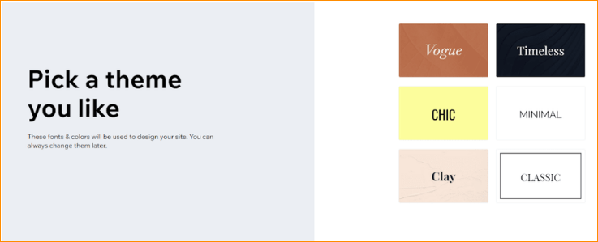

**Wix Pricing**

Wix plans include four premium plans and an enterprise plan, starting at the $16 per month Light plan. There is also a free plan:

* Free plan: – $0
* Light plan: – $16/month
* Core plan: – $27/month
* Business: – $32/month
* Business Elite: – $159/month
* Enterprise: – Custom pricing
* Can get AI features on all the plans, even the free one. However, big businesses may need more features, such as sales tools, extra storage space, or priority support, which will require upgrading to a paid plan. These paid plans can get quite expensive, going up to $159 per month for the enterprise-focused Elite Business plan.

**Wix AI Site Generator: The Future of Web Design**

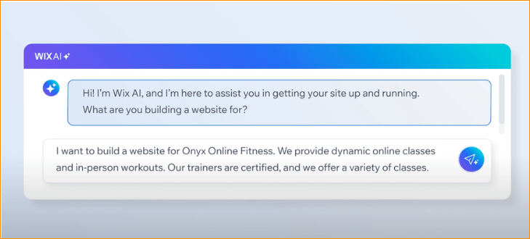

* Wix AI Site Generator will be coming soon to Wix users, where site creation is a matter of giving the AI a few prompts.
* It has also announced a few other AI tools including a Business Assistant.

From the Wix website builder to now seemingly the Wix AI builder. Wix users will be able to create a website in a matter of seconds, after inputting a few lines on what your website is designed to do. Simply type in the chat “I’d like a website for promoting my artwork” and this new tool promises to create your entire website, giving you options and asking you what you prefer along the way.

Wix has been at the

forefront of AI tools, already having an

* AI text creator,
* AI template text creator,
* AI image creator,
* Product descriptions, and more.

But it’s jumping on the trend to create an assistant to aid in answering business questions, along with the huge one – creating whole site.

Just highlight a suite of AI-powered capabilities that are already integrated into the Wix platform, many of which you probably already use. I also want to give you a glimpse into upcoming releases that will be available to soon.

Available now:

* AI Text Creator
* AI Template Text Creator
* Alternative Layouts
* AI Image Creator
* Auto Background Removal and Auto Enhance
* Auto-Generated Trailer
* Product Descriptions
* Product Recommendations
* AI Domain Generator

Coming soon:

* AI Site Generator
* AI Page and Section Creator
* Object Eraser
* AI Assistant for managing your business

1. AI Text Creator

Many of us use ChatGPT on a daily basis. Today, OpenAI’s ChatGPT is available inside Wix that’s call it the AI Text Creator. it combined Wix’s deep knowledge of site creation with ChatGPT to give the ability to generate high-quality content.

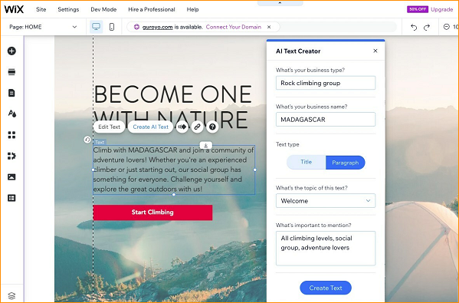

1. AI Templet Text Creator

If we want to create a new website and need content for all of the pages, including inner pages, can use ChatGPT with our AI Template Text Creator.

Just Provide a brief description of the website we want to create, and ChatGPT will create the text and content for the entire site. The tool will even make sure the text and the design are working well together.

1. Alternative Layouts

With the power of modern AI, we can use it not only for text but also to enhance our designs. The Alternative Layouts tool gives you the ability to redesign parts of your website in a single click.

1. AI Image Creator

High-quality images are an essential part of what makes a website look professional. in here AI-powered image editing tools is designed to help improve the visually significant attributes of images.

With the AI Image Creator, simply describe the image we want and a unique image will be generated.

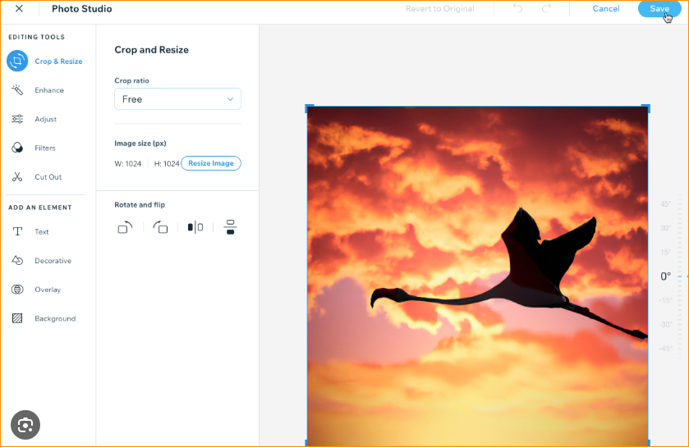 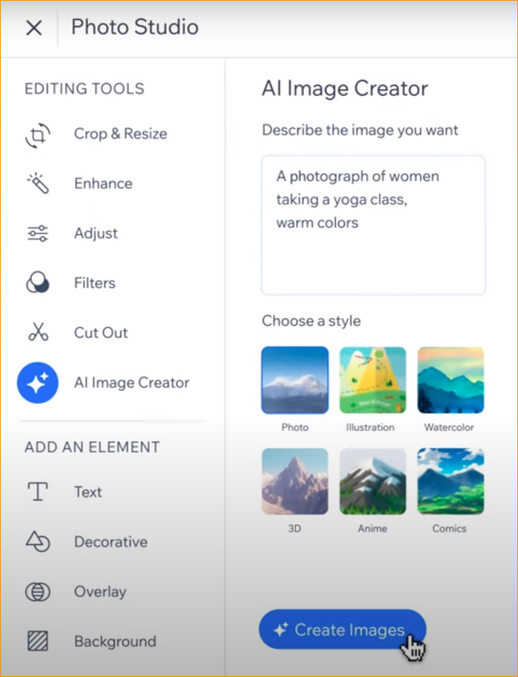

1. Auto Background Removal and Auto Enhance

can use the Auto Background Removal and Auto Enhance tools to refine photos and upgrade their quality to match the look and feel seek for ourwebsite.

1. Auto-Generated Trailer

tool that quickly transforms video files into professional-looking trailers.

1. AI eCommerce features to optimize your business - Product Descriptions

Product Descriptions make it simple to describe your eCommerce products almost instantly

1. Product Recommendations

target our customers with relevant products for them to buy. It is more traditional AI, but it does improve sales, mostly for stores with many products.

1. AI Domain Generator

can choose the perfect name for our brand from different options of unique, catchy and relevant domain names.

Upcomig –

1. AI Site Generator

which is truly the next generation of website creation.

given a prompt to input the website’s intent, ChatGPT generates the text while we generate the website design and images.

What makes it groundbreaking is that it is not a template. In fact, it’s a unique website designed and tailor-made for us, according to our needs, generated with AI and advanced algorithms. The design and layout are completely fitted to the site’s content.

It doesn't stop here. When we want to edit site, can prompt the tool to make high-quality changes

1. AI Page and Section Creator

If we already have a website, adding a page or a section will be so much faster. All we have to do is describe what we want and the page or section will be created with the layout, design and text.

1. AI Assistant for managing your business

Working on a new AI Assistant tool. It will suggest improvements for our website and create strategies based on personalized analytics and site trends. The best thing is that it will help us with our day-to-day tasks to take our business to the next level.

**Pros**

* Have a built website in a matter of minutes
* Automatically installs features you need
* AI Text Creator generates three options for each prompt

**Cons**

* Theme color choice is limited to six options
* Less help available than Wix Editor

Web site - <https://editor.wix.com/website/builder/?vertical=#!/intro/business-type>

Example -

**How to Create Website**



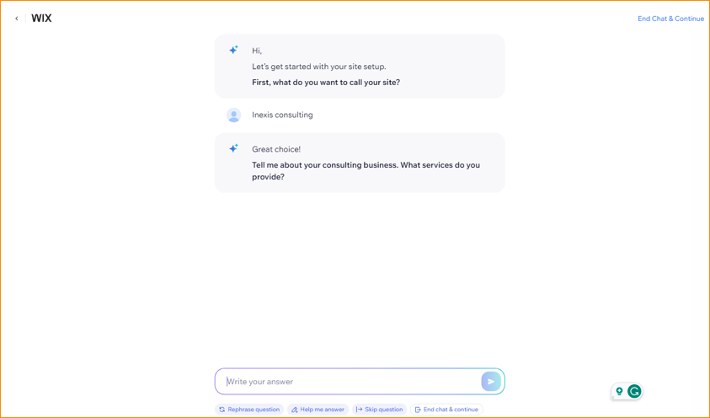

**Options-**



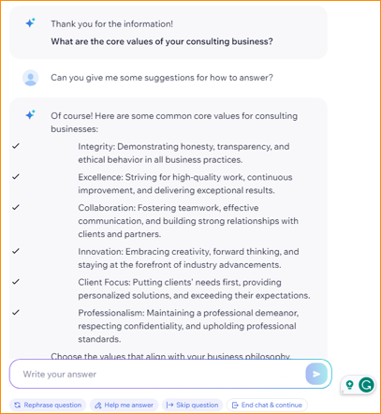 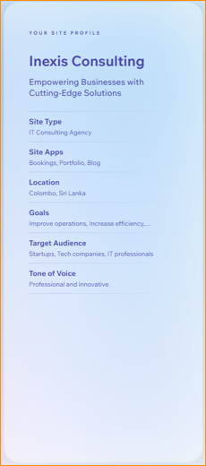

**Automatically creating website -**



Adding Service type-

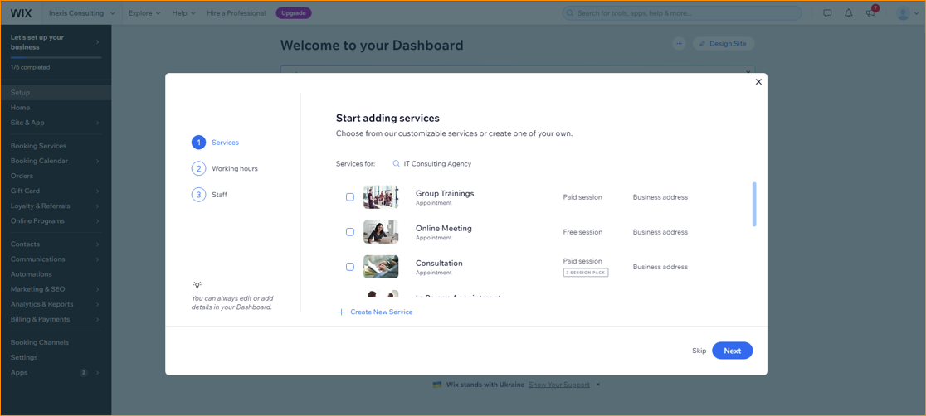

Working hours -

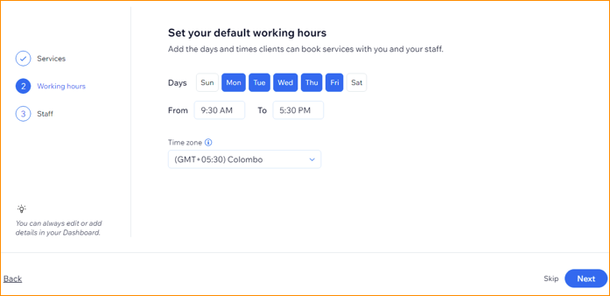

Add staffs -

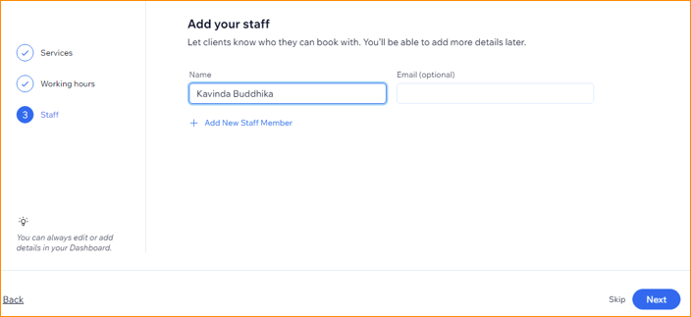

**Select Template –**

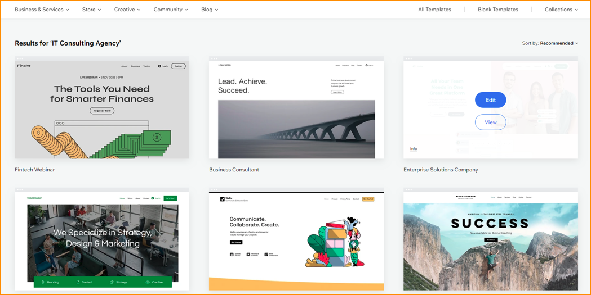

Basic structure of web site look like-

**Footer (Links/ Social Media/ Disclaimer)**

Strip 3

Strip 1

**Header (Menu/Social Media/Button / Login)**

Strip 2

Heading , Paragraph, Button

Paragraph

Offer, Gallery, Product

* Between Header and Footer we have content. Which is called strips when you use Wix and can add as many strip as we want.